Amadeus e-Power North America

**How To Remove The Double Scroll Bar**

Index

* *Steps to remove the double scroll bar* 3

# **Steps to remove the double scroll bar**

1. Create an iFrame on your website. Enter the following source code. *Note - replace the “YOUR PORTAL” section shown below with your own e-Power portal name.

<html>

<body>

<p></p>

<iframe src="https://www-amer.epower.amadeus.com/***YOUR PORTAL***/" width="100%" scrolling="no"></iframe>

<div id="callback"></div>

<script src="https://ajax.googleapis.com/ajax/libs/jquery/1.10.2/jquery.min.js"></script>

<script type="application/javascript" src="iframeResizer.min.js"></script>

<script type="application/javascript">

iFrameResize();

</script>

</body>

</html>

1. Download and activate the Development Bundle JQuery version 1.10.2 (shown below). Please follow their instructions on how to install. *If you already have this version installed, disregard this step.*

The URL to download is: <http://blog.jqueryui.com/2013/03/jquery-ui-1-10-2/>

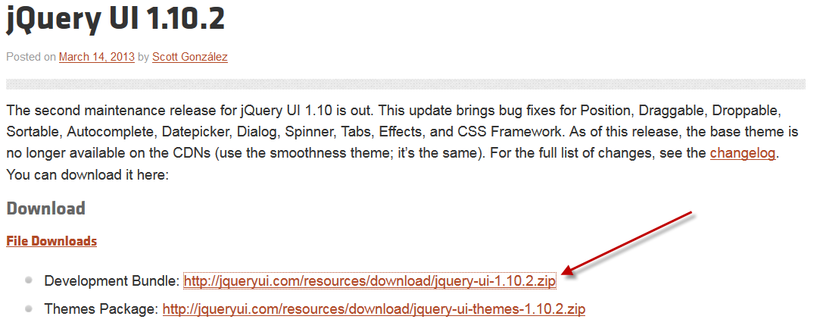

1. Install on your web server the iFrame Resizer javascript file. Double click the image below.



1. Save the iframeResizer.min file as a JavaScript File, Save the file to the designated folder you are using to store your Javascript files on your web server.

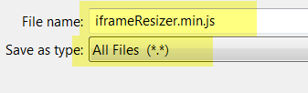

**\*Note - The iframeResizer.min file is configured with the common default settings.**

**Based on your website layout you may need to modify the iframeResizer.min file with the settings to meet your needs. You are responsible for updating the settings on this file.**